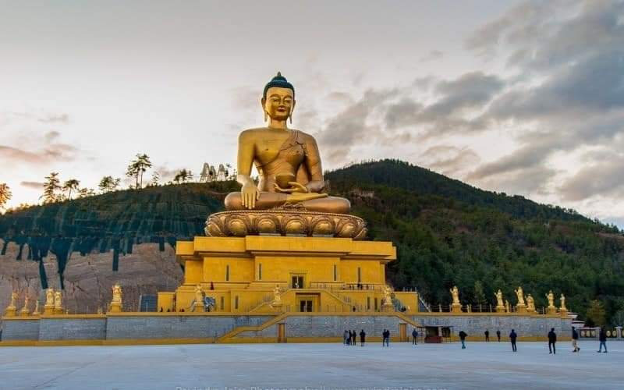

**6 NIGHTS AND 7 DAYS (Fly In Fly Out)**

|  |  |
| --- | --- |
| **No. of pax** | **4 Stars** |
| **02** | **$2280 PP** |
| **04** | **$2100 PP** |
| **06** | **$1920 PP** |
| **08 - 10** | **$1860 PP** |

|  |  |
| --- | --- |
| **No. of pax** | **Vehicle Types (Bhutan)** |
| **02 - 03** | **Creta / Santafee**  **Tucson / Celtos** |
| **04 -08** | **Etriga / Hiace** |
| **09 and above** | **Coaster Bus** |

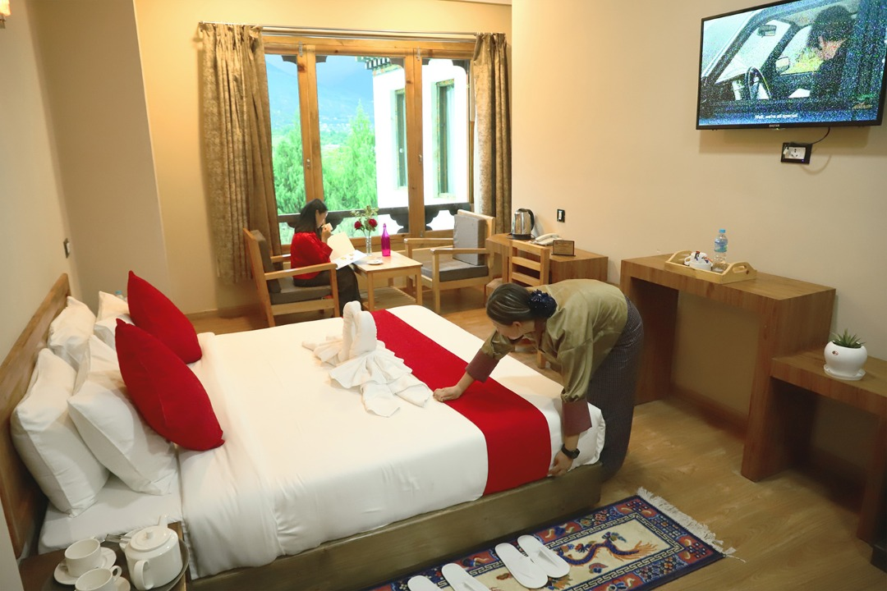

**4 Stars Hotels**

|  |  |  |
| --- | --- | --- |
| **Sl.no** | **Hotel Name** | **Location** |
| **1** | **Ramada Valley / City Hotel / Ariya Hotel** | **Thimphu** |
| **2** | **Four Boutique / River Valley** | **Punakha** |
| **3** | **Tashi Namgay Resort / The Grand Hotel / Kaachi Grand** | **Paro** |

**5 Stars Hotels**

|  |  |  |
| --- | --- | --- |
| **Sl.no** | **Hotel Name** | **Location** |
| **1** | **Dusit Thane / Le Meridien** | **Thimphu** |
| **2** | **Le Meridien** | **Paro** |
| **3** | **RKPO** | **Punakha** |

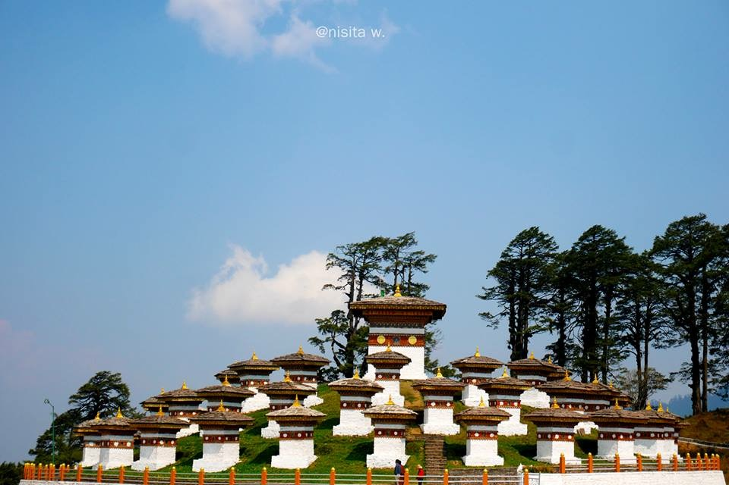

**(6 Nights / 7 Days) Fly In & Fly Out**

**(Thimphu 2N – Punakha 2N - Paro 2N)**

|  |  |  |
| --- | --- | --- |
| **Day** | **Plan** | **Night Stay** |
| **Day 1** | **Pick from Paro airport, drive to Thimphu. On arrival check in hotel and relax. Evening visit Tashichho Dzong (Fortress of the Glorious Religion) to see flag hoisting ceremony. Stay at Thimphu .** | **Thimphu** |
| **Day 2** | **After breakfast, start your day with sightseeing at Thimphu by visiting memrorial chorten, Buddha statue and Simply Bhutan (living museum) will get in house lady guide. Evening explore town and visit local shops and restaurant. Overnight stay at Thimphu.** | **Thimphu** |
| **Day 3** | **After breakfast drive to Punakha. Arrival at Punakha visit Punakha Dzong - built in 1637 by Zhabdrung Ngawang Namgyal. For many years until the time of the second king, it served as the seat of the Government. The Dzong was named Druk Pungthang Dechen Phodrang (Palace of Great Happiness). Punakha is still the winter residence of Je-Khenpo and King Jigme Dorji Wangchuck convened the first National Assembly here in 1952 and check in hotel. Overnight stay at Punakha.** | **Punakha** |
| **Day 4** | **After breakfast, go for Rafting in Punakha [ OPTIONAL ] OR Day excursion to Phobjikha. Visit Chimmi Lhakhang and evening explore town and relax, stay at Punakha.** | **Punakha** |
| **Day 5** | **After breakfast drive from Punakha to Paro, on than way stop for TAMGCHOG IRON BRIDGE, check in to the hotel. Evening visit Ta Dzong and Rinpung Dzong, if time permits explore Paro town. Stay in Hotel at Paro.** | **Paro** |
| **Day 6** | **After breakfast visit famous Taktsang Monastery - called “Tiger's Nest” (2-3 hrs hike from the base camp) & Kyichu Monastery. Evening visit Ta Dzong and Rinpung Dzong, Hot stone bath [OPTIONAL]. Overnight stay will be at Paro.** | **Paro** |
| **Day 7** | **Drive to airport for next destination with memories.** | **Destination** |

**END OF THE TOUR!!**

**COST INCLUDES:**

. Accommodation on Double/ Twin Sharing Basis.

· APAI plan basis.

· Exclusive Vehicle for transfers & sightseeing.

**. Vehicle will be available as per itinerary only. Not at disposal. 9am-5pm.after 5 pm extra charges apply.**

· All hotel taxes etc.

 English speaking GUIDE AND driver throughout the tour

. SDF $100 PER PERSON PER NIGHT

. Visa Fee $40

. Insurances of 600 per person.

**Package Cost Excludes:**

1.Tipping

2. Personal Insurance

3. Any personal consumption made which is not included in the package

4. Alcoholic drinks and special non Alcoholic cocktails, non-alcoholic beverages, aerated drinks, and non-aerated drinks.

5. Laundry charges at hotel stays.

6. ENTRANCE FEES AT THE HISTORICAL MONUMENTS.

7.Lunch in whole tour.

CANCELLATION POLICY

***. Booking Cancellation before 60 days will not be charged.***

***2. Booking Cancellation before 30 days - 50% of the booking cost WILL BE CHARGED***

***3. Booking Cancellation LESS THAN 30 days - 100% of the booking cost WILL BE CHARGED***

https://ssl.gstatic.com/ui/v1/icons/mail/images/cleardot.gif

TASHI DELEK [ THANK YOU ]