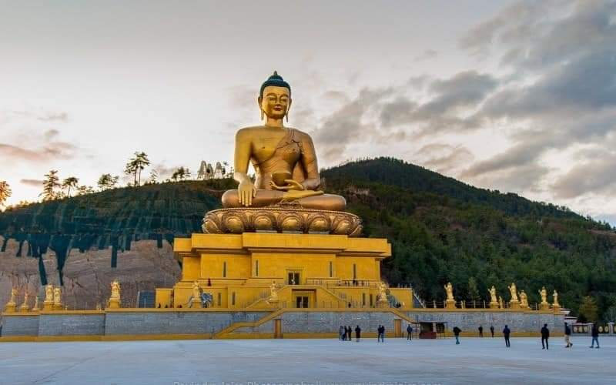

**3 NIGHTS AND 4 DAYS (Fly In Fly Out)**

|  |  |  |
| --- | --- | --- |
| **No. of pax** | **4 Stars** | **5 Stars** |
| **02** | **$1440 PP** |  |
| **04** | **$1050 PP** |  |
| **06** | **$960 PP** |  |
| **08 - 10** | **$940 PP** |  |

|  |  |  |  |
| --- | --- | --- | --- |
| **Child with Extra Bed** |  |  |  |
| **Child without Extra Bed** |  |  |  |

|  |  |
| --- | --- |
| **No. of pax** | **Vehicle Types (Bhutan)** |
| **02 - 03** | **Creta / Santafee**  **Tucson / Celtos** |
| **04 -08** | **Etriga / Hiace** |
| **09 and above** | **Coaster Bus** |

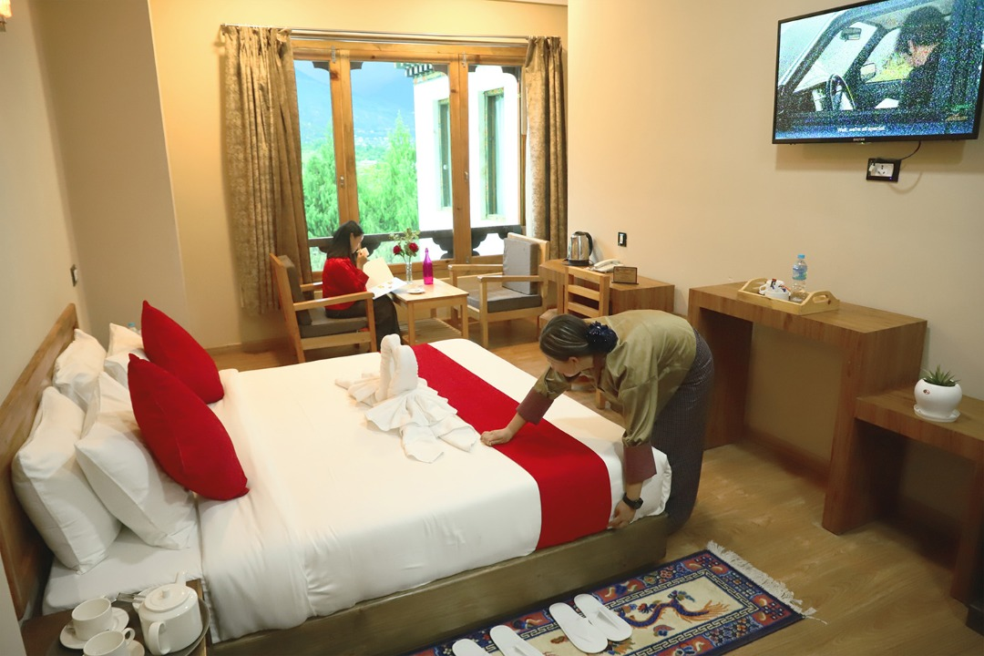

**4 Stars Hotels**

|  |  |  |
| --- | --- | --- |
| **Sl.no** | **Hotel Name** | **Location** |
| **1** | **Ramada Valley / City Hotel / Ariya Hotel** | **Thimphu** |
| **2** | **Four Boutique / River Valley** | **Punakha** |
| **3** | **Tashi Namgay Resort / The Grand Hotel / Kaachi Grand** | **Paro** |

**5 Stars Hotels**

|  |  |  |
| --- | --- | --- |
| **Sl.no** | **Hotel Name** | **Location** |
| **1** | **Dusit Thane / Le Meridien** | **Thimphu** |
| **2** | **Le Meridien** | **Paro** |
| **3** | **RKPO** | **Punakha** |

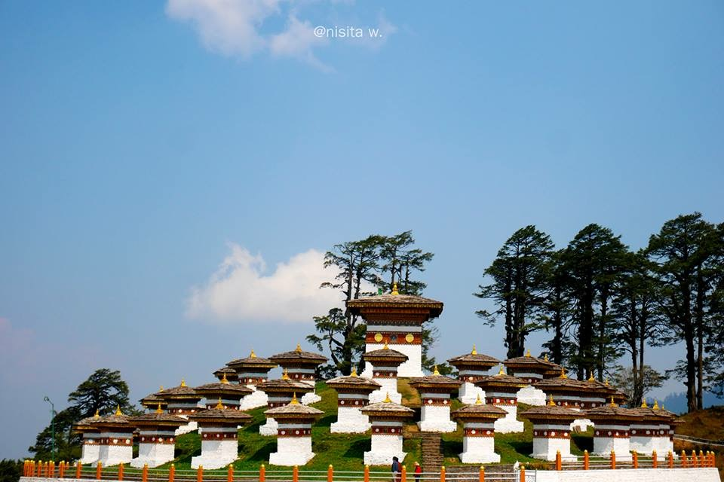

**(3 Nights / 4 Days) Fly In & Fly Out**

**(Thimphu 1N – Paro 2N)**

|  |  |  |
| --- | --- | --- |
| **Day** | **Plan** | **Night Stay** |
| **Day 1** | **Pick from Paro airport, drive to Thimphu sightseeing On arrival, visit memorial chorten, Buddha Point and Simply Bhutan (living museum) and explore town. After that check in hotel and relax.**  **Evening visit Tashichho Dzong (Fortress of the Glorious Religion) to see flag hoisting ceremony.**  **Stay at Thimphu .** | **Thimphu** |
| **Day 2** | **After breakfast drive from Thimphu to Paro, on than way stop for TAMGCHOG IRON BRIDGE and airport view. On arrival check in to the hotel. Evening visit Ta Dzong and Rinpung Dzong, if time permits explore Paro town. Stay in Hotel at Paro.** | **Paro** |
| **Day 3** | **Taktsang Monastery - called “Tiger's Nest” (2-3 hrs hike from the base camp) & Kyichu Monastery. Evening relax and stay at hotel.** | **Paro** |
| **Day 4** | **After a successful trip drop to airport for onward journey** | **Destination** |

**END OF THE TOUR!!**

**COST INCLUDES:**

. Accommodation on Double/ Twin Sharing Basis.

· APAI plan basis.

· Exclusive Vehicle for transfers & sightseeing.

**. Vehicle will be available as per itinerary only. Not at disposal. 9am-5pm.after 5 pm extra charges apply.**

· All hotel taxes etc.

 English speaking GUIDE AND driver throughout the tour

. SDF $100 PER PERSON PER NIGHT

. Visa Fee $40

. Insurances of 600 per person.

**Package Cost Excludes:**

1.Tipping

2. Personal Insurance

3. Any personal consumption made which is not included in the package

4. Alcoholic drinks and special non Alcoholic cocktails, non-alcoholic beverages, aerated drinks, and non-aerated drinks.

5. Laundry charges at hotel stays.

6. ENTRANCE FEES AT THE HISTORICAL MONUMENTS.

7.Lunch in whole tour.

CANCELLATION POLICY

***. Booking Cancellation before 60 days will not be charged.***

***2. Booking Cancellation before 30 days - 50% of the booking cost WILL BE CHARGED***

***3. Booking Cancellation LESS THAN 30 days - 100% of the booking cost WILL BE CHARGED***

https://ssl.gstatic.com/ui/v1/icons/mail/images/cleardot.gif

TASHI DELEK [ THANK YOU ]