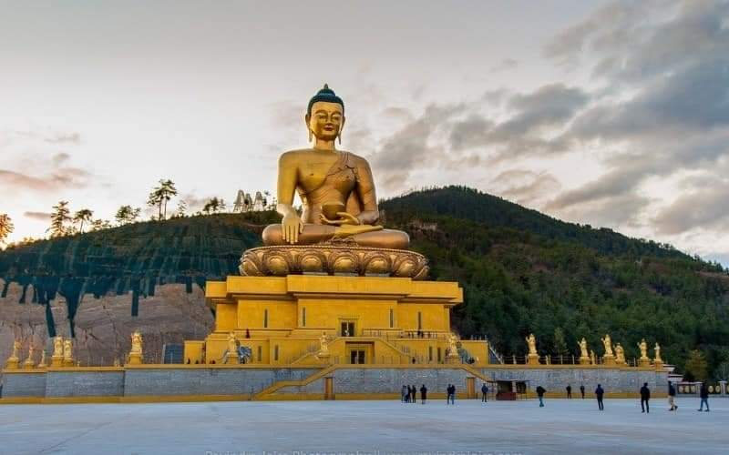

**9 NIGHTS AND 10 DAYS (Fly In Fly Out)**

|  |  |  |
| --- | --- | --- |
| **No. of pax** | **4 Stars** | **5 Stars** |
| **06** | **$1550 PP** |  |
| **08** | **$1500 PP** |  |
| **12** | **$1480 PP** |  |
| **14** | **$1435 PP** |  |

|  |  |  |  |
| --- | --- | --- | --- |
| **Child with Extra Bed** |  |  |  |
| **Child without Extra Bed** |  |  |  |

|  |  |
| --- | --- |
| **No. of pax** | **Vehicle Types (Bhutan)** |
| **02 - 03** | **Creta / Santafee**  **Tucson / Celtos** |
| **04 -08** | **Etriga / Hiace** |
| **09 and above** | **Coaster Bus** |

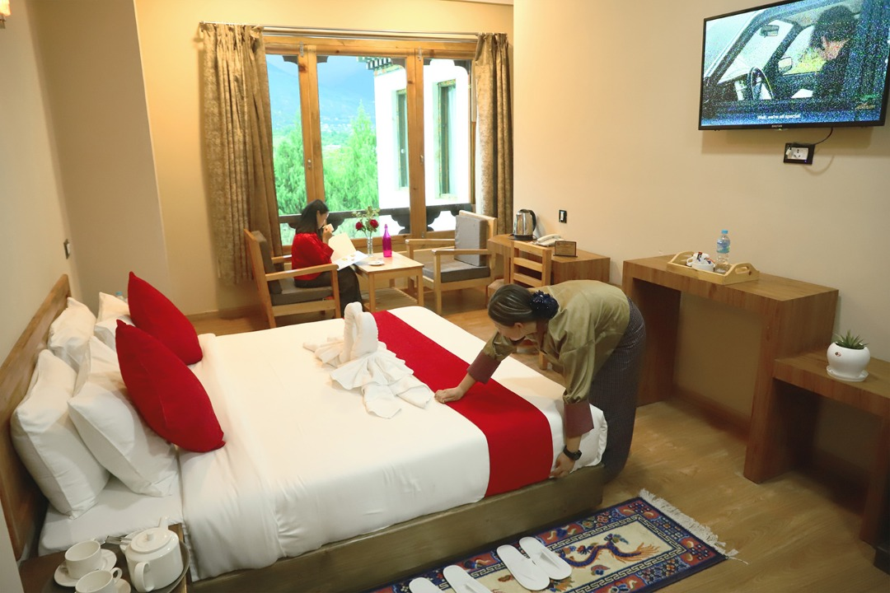

**4 Stars Hotels**

|  |  |  |
| --- | --- | --- |
| **Sl.no** | **Hotel Name** | **Location** |
| **1** | **Ramada Valley / City Hotel / Ariya Hotel** | **Thimphu** |
| **2** | **Four Boutique / River Valley** | **Punakha** |
| **3** | **Tashi Namgay Resort / The Grand Hotel / Kaachi Grand** | **Paro** |

**5 Stars Hotels**

|  |  |  |
| --- | --- | --- |
| **Sl.no** | **Hotel Name** | **Location** |
| **1** | **Dusit Thane / Le Meridien** | **Thimphu** |
| **2** | **Le Meridien** | **Paro** |
| **3** | **RKPO** | **Punakha** |

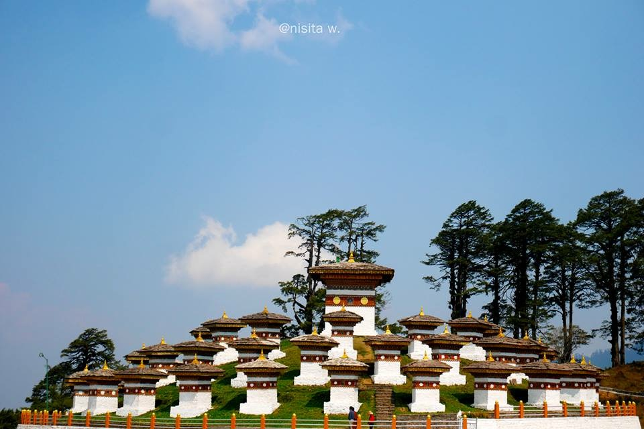

**(9 Nights / 10 Days) Drive In & Drive Out** **.**

**(Thimphu 2N – Phobjikha 2N – Punakha 1N – Bumthang 2N - Paro 2N)**

**Day 01: Paro Airport - Thimphu**

Meet & Greet on arrival at Paro airport and transfer to **Thimphu** (7,710 ft.) **the capital city of Bhutan**. Enroute stop at **Chhuzom,** confluence of **Wang Chhu** and **Pa Chhu** rivers. On arrival check in the hotel. In the evening, visit the **Tashichho Dzong** (Fortress of the Glorious Religion). Overnight stay at Thimphu.

**Day 02: Thimphu sightseeings**

After breakfast visit **Kuensel Phodrang** (Buddha Statue) a place for refreshing with a huge statue of Buddha on the top of the Kuensel Phodrang, N**ational Memorial Chorten** (Monument) & **Simply Bhutan (living museum)** will get in house lady guide. **Takin Preserve Centre**, the national animal of Bhutan can be seen here. Overnight stay at Thimphu.

**Day 03: Thimphu - Phobjikha**

After breakfast drive to **punakha via Dochula pass**, stop for **Lampari park** for a glace and after that transfer to Phobjikha Valley which is a vast U – shaped valley in central Bhutan. The valley houses one of the impressive ancient Buddhist monasteries in Bhutan known as Gangteng Monastery of the Nyingma sect in central Bhutan. Overnight stay at hotel in Phobjikha.

**Day 04: Phobjikha sightseeing**

After breakfast visit Gangteng Monastery also known as **Gangtey Goenpa** on a spur surrounded by the village of Gangtey. Evening time relax time. Stay at hotel.

**Day 05: Phobjikha – Bumthang**

After breakfast, drive to Bumthang. It is one of the most beautiful and sacred valleys in Bhutan and the main town in the valley is **Jakar**. On arrival check in hotel. Evening explore town and visit some local shops and restaurant. Overnight stay at Bumthang.

**Day 06: Bumthang Sightseeing**

After breakfast visit many significant Buddhist sacred sites nearby the town, such as **[Kurjey Lhakhang](https://en.wikipedia.org/wiki/Kurjey_Lhakhang" \o "Kurjey Lhakhang)**, which holds a body print of Guru Rinpoche, **Jambey Lhakhang**, one of the 108 monasteries that in mythology were miraculously constructed by King Songten Gampo in one night and **Tamsshing Lhakhag** established by **[Terton Padma](https://en.wikipedia.org/wiki/Pema_Lingpa" \o "Pema Lingpa)****[Lingpa](https://en.wikipedia.org/wiki/Pema_Lingpa" \o "Pema Lingpa)** (1450–1521), after that visit one of the country's largest monastic colleges, **Lhodrak Kharchhu Monastery**, overlooks Jakar. Evening relax and stay at hotel.

**Day 07: Bumthang – Punakha**

After breakfast drive to Punakha, on arrival visit **Punakha Dzong** - built in 1637 by Zhabdrung Ngawang Namgyal. For many years until the time of the second king, it served as the seat of the Government. The Dzong was named Druk Pungthang Dechen Phodrang (Palace of Great Happiness). Punakha is still the winter residence of Je-Khenpo and King Jigme Dorji Wangchuck convened the first National Assembly here in 1952. Overnight stay at Punakha.

**Day 08: Punakha - Paro**

After breakfast drive from Punakha to Paro, on the way to Paro visit **Tamchog Lhangkhag [Iron Bridge**] and on arrival check in hotel. Evening visit **Ta Dzong and Rinpung Dzong**. Overnight stay will be at Paro.

**Day 09**: **Paro Sightseeing**

After breakfast visit famous **Taktsang Monastery - called “Tiger's Nest**” (2-3 hrs hike from the base camp) and visit **Kyichu Monastery.** Try **Hot Stone bath** **(OPTIONAL).** Evening relax and spent your own time. Stay at hotel.

**Day 10: Paro Airport**

After breakfast check out from the hotel and drive to the airport transfer with smiling faces.

**END OF THE TOUR!!**

**COST INCLUDES:**

. Accommodation on Double/ Twin Sharing Basis.

· CPAI Meal plan basis.

· Exclusive Vehicle for transfers & sightseeing.

**. Vehicle will be available as per itinerary only. Not at disposal. 9am-5pm.after 5 pm extra charges apply.**

· All hotel taxes etc.

 English speaking GUIDE AND driver throughout the tour.

. SDF $100 per night per person.

. Visa fee $40.

**Package Cost Excludes:**

1.Tipping

2. Personal Insurance

3. Any personal consumption made which is not included in the package

4. Alcoholic drinks and special non Alcoholic cocktails, non-alcoholic beverages, aerated drinks, and non-aerated drinks.

5. Laundry charges at hotel stays.

6. ENTRANCE FEES AT THE HISTORICAL MONUMENTS.

7.Lunch and dinner in whole tour.

CANCELLATION POLICY

***. Booking Cancellation before 60 days will not be charged.***

***2. Booking Cancellation before 30 days - 50% of the booking cost WILL BE CHARGED***

***3. Booking Cancellation LESS THAN 30 days - 100% of the booking cost WILL BE CHARGED***

https://ssl.gstatic.com/ui/v1/icons/mail/images/cleardot.gif

TASHI DELEK [ THANK YOU ]