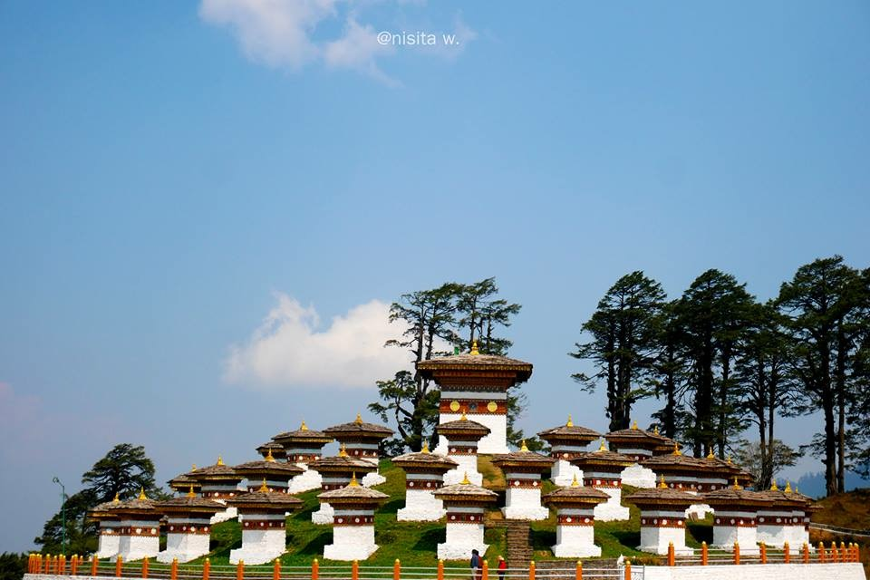

**4 NIGHTS AND 5 DAYS (Drive In Drive Out)**

|  |  |  |  |
| --- | --- | --- | --- |
| **No. of pax** | **3 Stars** | **4 Stars** | **5 Stars** |
| **02** | **30,140/-** | **38,600/-** | **50,360/-** |
| **04** | **21,440/-** | **29,900/-** | **43,310/-** |
| **06** | **19,130/-** | **27,590/-** | **43,850/-** |
| **08** | **20,690/-** | **29,150/-** | **45,410/-** |
| **10** | **18,860/-** | **31,820/-** | **28,670/-** |

|  |  |  |  |
| --- | --- | --- | --- |
| **Child with Extra Bed** |  |  |  |
| **Child without Extra Bed** |  |  |  |

|  |  |  |
| --- | --- | --- |
| **No. of pax** | **Vehicle Types (Bhutan)** | **Vehicle Types**  **( India )** |
| **02 - 03** | **Creta / Santafee**  **Tucson / Celtos** | **Wagnor**  **SUV** |
| **04 -08** | **Etriga / Hiace** | **Inova** |
| **09 and above** | **Coaster Bus** |  |

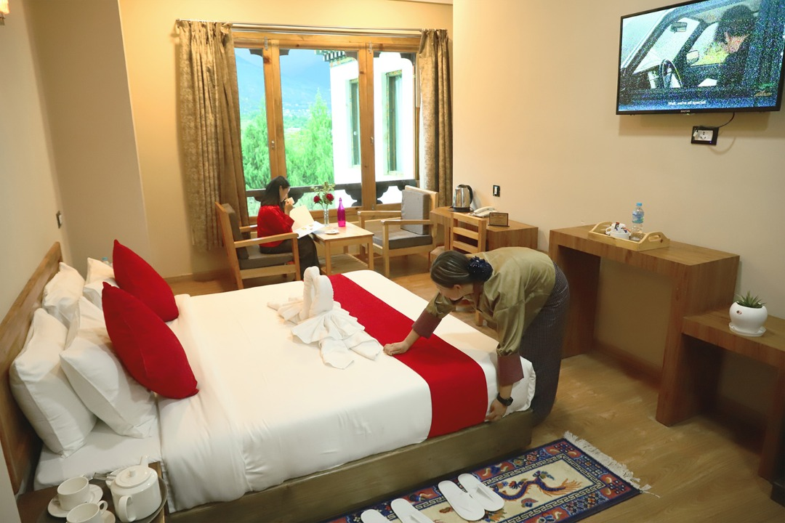

**3 Stars Hotels**

|  |  |  |
| --- | --- | --- |
| **Sl.no** | **Hotel Name** | **Location** |
| **1** | **Alem Resort / Meto Pema** | **Phuentsholing** |
| **2** | **Lhayul Hotel / Nordenma** | **Thimphu** |
| **3** | **Punakha Residency / Sonam Gang /** | **Punakha** |
| **4** | **Central Point Hotel / Tshongdu Boutique** | **Paro** |

**4 Stars Hotels**

|  |  |  |
| --- | --- | --- |
| **Sl.no** | **Hotel Name** | **Location** |
| **1** | **Hotel Palm / Ga Me Ga** | **Phuentsholing** |
| **2** | **Ramada Valley / City Hotel / Ariya Hotel / Pelyang Boutique / Migmar** | **Thimphu** |
| **3** | **Four Boutique / River Valley** | **Punakha** |
| **4** | **Tashi Namgay Resort / The Grand Hotel / Kaachi Grand** | **Paro** |

**5 Stars Hotels**

|  |  |  |
| --- | --- | --- |
| **Sl.no** | **Hotel Name** | **Location** |
| **1** | **Palm Hotel** | **Phuentsholing** |
| **2** | **Dusit Thane** | **Thimphu** |
| **3** | **Le Meridien** | **Paro** |
| **4** | **RKPO** | **Punakha** |

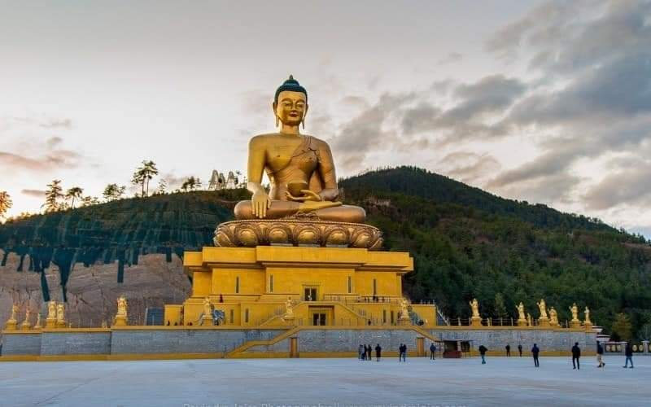

**(4 Nights / 5 Days) Drive In & Drive Out** **.**

**(Phuentsholing 1N – Thimphu 2 – Paro 1N)**

**Day 01: Cooch Behar /Alipur Duar/bagdogra – Phuentsholing**

Meet & Greet on arrival at Cooch Behar / Alipur duar and transfer to Phuentsholing - The Gateway of Bhutan by Road from India. It is a thriving commercial center on the northern edge of the Indian Plains. On arrival check in at the hotel. Overnight stay at Phuentsholing.

**Day 02: Phuentsholing – Thimphu**

**(Distance:176 kms./Driving Time:6 hrs./ Altitude of Thimphu: 2350 mts.)**

After breakfast complete the immigration formalities and transfer to Thimphu (7,710 ft.) the capital city of Bhutan. On arrival check in at the hotel. In the evening, visit the **Tashichho Dzong** (Fortress of the Glorious Religion). Overnight stay at Thimphu.

**Day 03: Thimphu Sightseeing**

After breakfast visit **Kuensel Phodrang** (Buddha Statue) a place for refreshing with a huge statue of Buddha on the top of the Kuensel Phodrang, N**ational Memorial Chorten** (Monument) & **Simply Bhutan (Living museum) will get in house lady guide** and **Takin Preserve Centre**, the national animal of Bhutan can be seen here,overnight stay at Thimphu.

**Day 04: Paro Sightseeing**

After breakfast visit famous **Taktsang Monastery - called “Tiger's Nest**” (2-3 hrs hike from the base camp) &**Kyichu Monastery**. Evening visit Ta Dzong and Rinpung Dzong. Overnight stay will be at Paro.

**Day 05: Paro – Phuentsholing to Cooch Behar /Alipur Duar/bagdogra**

After breakfast drive to Phuentsholing, on arrival change the vehicle and proceed towards your onward journey.

Thanks.

……………………………………………………………………………………………………………………………….

**INCLUDES**

* Accommodation on Double/ Twin Sharing Basis
* Accommodation in twin sharing basis
* Meal Serve in Hotel as per hotel fix menu basis.
* Exclusive Vehicle for transfers & sightseeing.
* Vehicle will be available as per itinerary only. Not at disposal. 9am-5pm.after 5 pm extra charges     apply.
* Base category room used in the package.
* All hotel taxes etc.
* English speaking GUIDE AND driver throughout the tour. Only Bhutan part.
* One Local Sim card.
* One ltr mineral water bottle during sightseeing time only.
* SDF of 1200 per night per person
* Insurances of 600 per person

**EXCLUSIVE**

1. Tipping
2. Personal Insurance
3. Any personal consumption made which is not included in the package
4. Alcoholic drinks and special non Alcoholic cocktails, non-alcoholic beverages, aerated drinks and non-aerated drinks.
5. Laundry charges at hotel stays
6. Entrance fee at the historical monuments.

TASHI DELEK [THANK YOU]