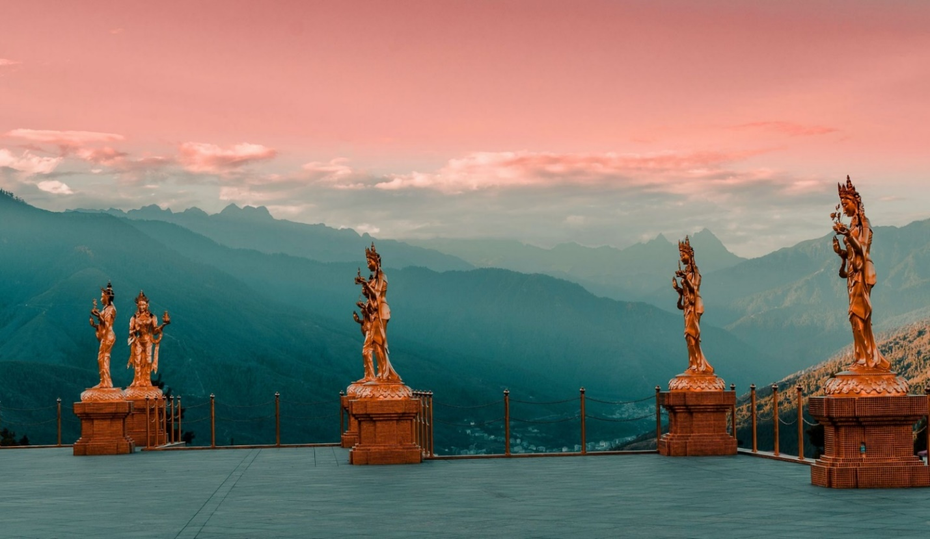

**4 NIGHTS AND 5 DAYS (Fly In Fly Out)**

|  |  |  |  |
| --- | --- | --- | --- |
| **No. of pax** | **3 Stars** | **4 Stars** | **5 Stars** |
| **02** | **28,100/-** | **38,300/-** | **58,460/-** |
| **04** | **20,600/-** | **30,800/-** | **50,960/-** |
| **06** | **19,100/-** | **29,300/-** | **49,460/-** |
| **08** | **19,850/-** | **30,050/-** | **50,210/-** |
| **10** | **18,500/-** | **28,700/-** | **48,860/-** |

|  |  |  |  |
| --- | --- | --- | --- |
| **Child with Extra Bed** |  |  |  |
| **Child without Extra Bed** |  |  |  |

|  |  |
| --- | --- |
| **No. of pax** | **Vehicle Types (Bhutan)** |
| **02 - 03** | **Creta / Santafee**  **Tucson / Celtos** |
| **04 -08** | **Etriga / Hiace** |
| **09 and above** | **Coaster Bus** |

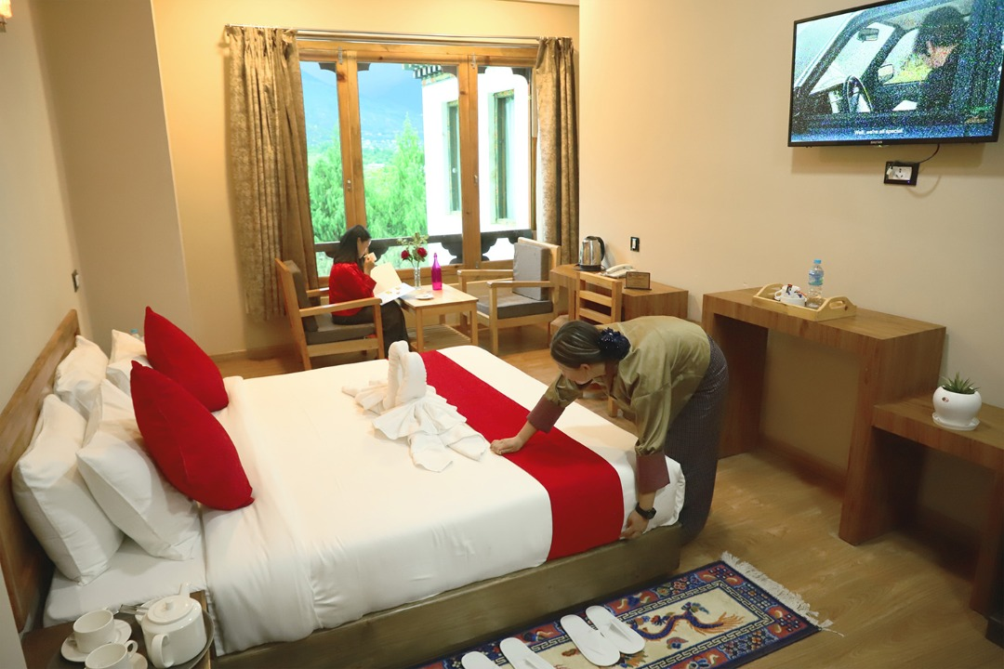

**3 Stars Hotels**

|  |  |  |
| --- | --- | --- |
| **Sl.no** | **Hotel Name** | **Location** |
| **1** | **Lhayul Hotel / Nordenma** | **Thimphu** |
| **2** | **Punakha Residency / Sonam Gang /** | **Punakha** |
| **3** | **Golden Paddy Field / Tshongdu Boutique** | **Paro** |

**4 Stars Hotels**

|  |  |  |
| --- | --- | --- |
| **Sl.no** | **Hotel Name** | **Location** |
| **1** | **Ramada Valley / City Hotel / Ariya Hotel / Pelyang Boutique / Migmar** | **Thimphu** |
| **2** | **Four Boutique / River Valley** | **Punakha** |
| **3** | **Tashi Namgay Resort / The Grand Hotel / Kaachi Grand** | **Paro** |

**5 Stars Hotels**

|  |  |  |
| --- | --- | --- |
| **Sl.no** | **Hotel Name** | **Location** |
| **1** | **Dusit Thane** | **Thimphu** |
| **2** | **Le Meridien** | **Paro** |
| **3** | **RKPO** | **Punakha** |

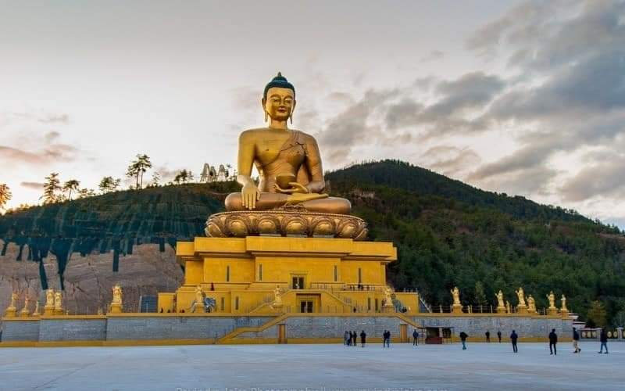

**(4 Nights / 5 Days) Fly In & Fly** **Out.**

**(Thimphu 2N – Punakha 1N – Paro 1N)**

|  |  |  |
| --- | --- | --- |
| **Day** | **Plan** | **Night Stay** |
| **Day 1** | **Pick from Paro airport, drive to Thimphu sightseeing.** | **Thimphu** |
| **Day 2** | **After Breakfast start your day with sightseeing at Thimphu by visiting memrorial chorten, Buddha statue and Simply Bhutan. Visit Tashichho Dzong (Fortress of the Glorious Religion)**  **Stay at Thimphu .** | **Thimphu** |
| **Day 3** | **After breakfast drive to Punakha. Arrival at Punakha visit Punakha Dzong - built in 1637 by Zhabdrung Ngawang Namgyal. For many years until the time of the second king, it served as the seat of the Government. The Dzong was named Druk Pungthang Dechen Phodrang (Palace of Great Happiness). Punakha is still th winter residence of Je-Khenpo and King Jigme Dorji Wangchuck convened the first National Assembly here in 1952, and Chimi Lhakhang Temple. Overnight stay at Punakha.** | **Punakha** |
| **Day 4** | **After breakfast drive from Punakha to Paro on than way stop for TAMGCHOG IRON BRIDGE, check in to the hotel. Evening visit Ta Dzong and Rinpung Dzong, if time permits explore Paro town. Stay in Hotel at Paro.** | **Paro** |
| **Day 5** | **Drive to airport for next destination with memories** | **Destination** |

**END OF THE TOUR!!!**

**INCLUDES**

* Accommodation on Double/ Twin Sharing Basis
* Accommodation in twin sharing basis
* Meal Serve in Hotel as per hotel fix menu basis.
* Exclusive Vehicle for transfers & sightseeing.
* Vehicle will be available as per itinerary only. Not at disposal. 9am-5pm.after 5 pm extra charges     apply.
* Base category room used in the package.
* All hotel taxes etc.
* English speaking GUIDE AND driver throughout the tour. Only Bhutan part.
* One Local Sim card.
* One ltr mineral water bottle during sightseeing time only.
* SDF of 1200 per night per person
* Insurances of 600 per person

**EXCLUSIVE**

1. Tipping
2. Personal Insurance
3. Any personal consumption made which is not included in the package
4. Alcoholic drinks and special non Alcoholic cocktails, non-alcoholic beverages, aerated drinks and non-aerated drinks.
5. Laundry charges at hotel stays
6. Entrance fee at the historical monuments.

TASHI DELEK [THANK YOU]