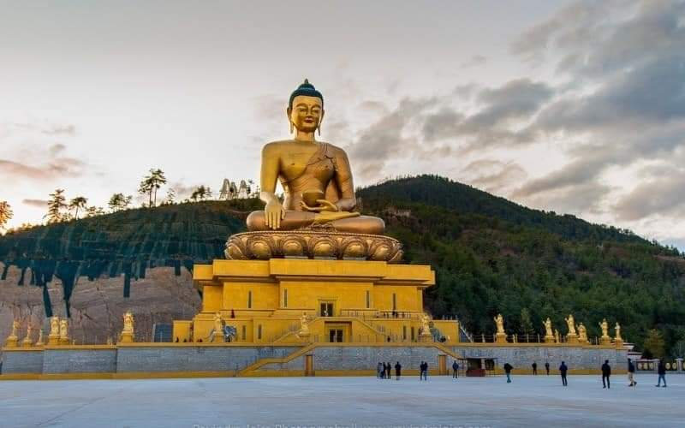

**5NIGHTS AND 6DAYS [ FLY IN FLY OUT ]**

|  |  |  |  |
| --- | --- | --- | --- |
| **No. of pax** | **3 Stars** | **4 Stars** | **5 Stars** |
| **02** | **34,340/-** | **46,400/-** | **75,500/-** |
| **04** | **26,060/-** | **37,400/-** | **66,500/-** |
| **06** | **20,970/-** | **35,600/-** | **64,700/-** |
| **08** | **24,440/-** | **36,500/-** | **65,600/-** |
| **10** | **22,820/-** | **34,880/-** | **63,980/-** |

|  |  |  |  |
| --- | --- | --- | --- |
| **Child with Extra Bed** |  |  |  |
| **Child without Extra Bed** |  |  |  |

|  |  |
| --- | --- |
| **No. of pax** | **Vehicle Types (Bhutan)** |
| **02 - 03** | **Creta / Santafee**  **Tucson / Celtos** |
| **04 -08** | **Etriga / Hiace** |
| **09 and above** | **Coaster Bus** |

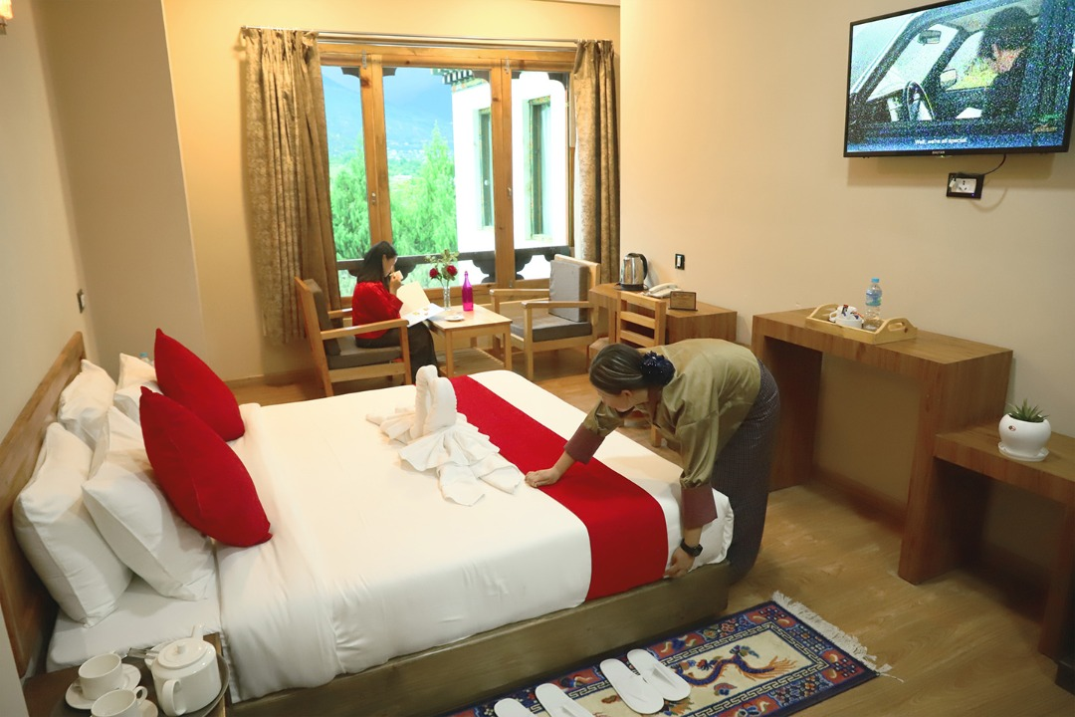

**3 Stars Hotels**

|  |  |  |
| --- | --- | --- |
| **Sl.no** | **Hotel Name** | **Location** |
| **1** | **Lhayul Hotel / Nordenma** | **Thimphu** |
| **2** | **Punakha Residency / Sonam Gang /** | **Punakha** |
| **3** | **Golden Paddy Field / Tshongdu Boutique** | **Paro** |

**4 Stars Hotels**

|  |  |  |
| --- | --- | --- |
| **Sl.no** | **Hotel Name** | **Location** |
| **1** | **Ramada Valley / City Hotel / Ariya Hotel** | **Thimphu** |
| **2** | **Four Boutique / River Valley / Zhingkham Resort / Khuru Resort** | **Punakha** |
| **3** | **Tashi Namgay Resort / The Grand Hotel / Kaachi Grand** | **Paro** |

**5 Stars Hotels**

|  |  |  |
| --- | --- | --- |
| **Sl.no** | **Hotel Name** | **Location** |
| **1** | **Dusit Thane** | **Thimphu** |
| **2** | **Le Meridien** | **Paro** |
| **3** | **RKPO** | **Punakha** |

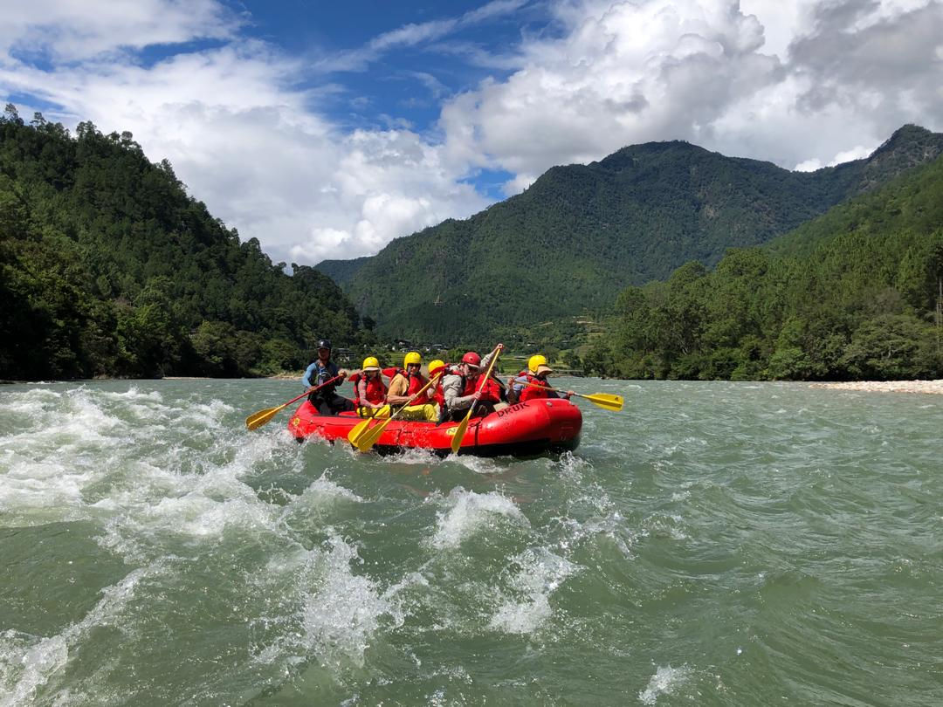

**(5 Nights / 6 Days) FLY In & FLY Out.**

**(Thimphu 2N – Punakha 1N -Paro 2N)**

|  |  |  |
| --- | --- | --- |
| **Day** | **Plan** | **Night Stay** |
| **Day 1** | **Pick from Paro airport, drive to Thimphu sightseeing.** | **Thimphu** |
| **Day 2** | **After Breakfast start your day with sightseeing at Thimphu visiting memorial chorten , Buddha statue and Simply Bhutan. Visit Tashichho Dzong (Fortress of the Glorious Religion)**  **Stay at Thimphu .** | **Thimphu** |
| **Day 3** | **Thimphu to Punakha On the way stop at Dochu-La-Pass ( 3150 mts ) to view the higher Himalayas  Visit Punakha Dzong - built in 1637 ChimiLhakhang Temple** | **Punakha** |
| **Day 4** | **Punakha to Paro, evening explore town and relax.** | **Paro** |
| **Day 5** | **Taktsang Monastery - called “Tiger's Nest” (2-3 hours hike from the base camp) & Kyichu Monastery. Evening visit Ta Dzong and Rinpung Dzong** | **Paro** |
| **Day 6** | **After a successful trip drop to airport for onward journey** | **Destination** |

**COST INCLUDES:**

. Accommodation on Double/ Twin Sharing Basis.

· Meal plan MAP basis.

· Exclusive Vehicle for transfers & sightseeing.

**. Vehicle will be available as per itinerary only. Not at disposal.9am-5pm.after 5 pm extra charges apply.**

· All hotel taxes etc.

• English speaking GUIDE AND driver throughout the tour.

* SDF of 1200 per night per person
* Insurance of 600 per person

**Package Cost Excludes:**

1.Tipping

2. Personal Insurance

3. Any personal consumption made which is not included in the package

4. Alcoholic drinks and special non Alcoholic cocktails, non-alcoholic beverages, aerated drinks, and non-aerated drinks.

5. Laundry charges at hotel stays.

6. ENTRANCE FEES AT THE HISTORICAL MONUMENTS.

7.Lunch in whole tour.

CANCELLATION POLICY

***. Booking Cancellation before 60 days will not be charged.***

***2. Booking Cancellation before 30 days - 50% of the booking cost WILL BE CHARGED***

***3. Booking Cancellation LESS THAN 30 days - 100% of the booking cost WILL BE CHARGED***

https://ssl.gstatic.com/ui/v1/icons/mail/images/cleardot.gif

TASHI DELEK [THANK YOU]