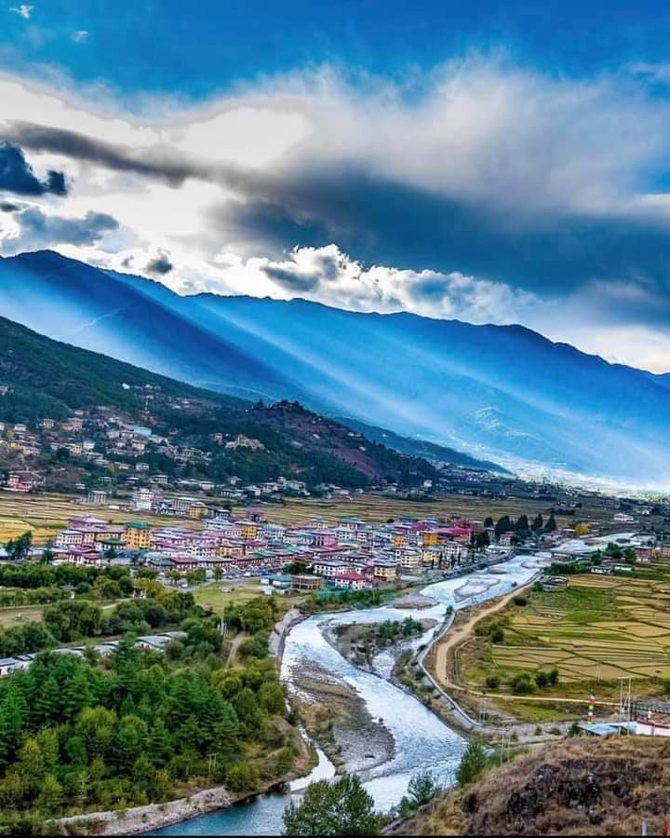

**6 NIGHTS AND 7 DAYS (Drive In Drive Out)**

|  |  |  |  |
| --- | --- | --- | --- |
| **No. of pax** | **3 Stars** | **4 Stars** | **5 Stars** |
| **02** | **40,940/-** | **48,200/-** | **83,000/-** |
| **04** | **30,740/-** | **42,500/-** | **72,800/-** |
| **06** | **28,130/-** | **39,890/-** | **83,950/-** |
| **08** | **29,840/-** | **41,600/-** | **71,900/-** |
| **10** | **27,740/-** | **39,500/-** | **69,800/-** |

|  |  |  |  |
| --- | --- | --- | --- |
| **Child with Extra Bed** |  |  |  |
| **Child without Extra Bed** |  |  |  |

|  |  |  |
| --- | --- | --- |
| **No. of pax** | **Vehicle Types (Bhutan)** | **Vehicle Types**  **( India )** |
| **02 - 03** | **Creta / Santafee**  **Tucson / Celtos** | **Wagnor**  **SUV** |
| **04 -08** | **Etriga / Hiace** | **Innova** |
| **09 and above** | **Coaster Bus** | **Tempo Traveler** |

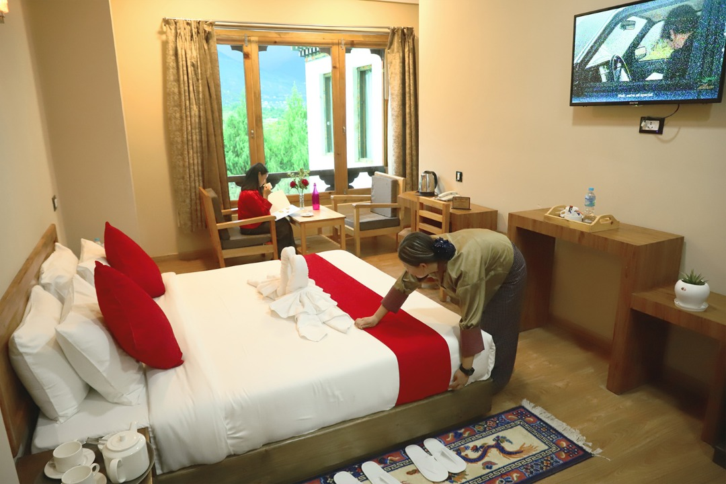

**3 Stars Hotels**

|  |  |  |
| --- | --- | --- |
| **Sl.no** | **Hotel Name** | **Location** |
| **1** | **Alem Resort / Meto Pema** | **Phuentsholing** |
| **2** | **Lhayul Hotel / Nordenma** | **Thimphu** |
| **3** | **Punakha Residency / Sonam Gang / Meri Puensum** | **Punakha** |
| **4** | **Tshongdu Boutique / Hotel Golden Paddy Field** | **Paro** |

**4 Stars Hotels**

|  |  |  |
| --- | --- | --- |
| **Sl.no** | **Hotel Name** | **Location** |
| **1** | **Hotel Palm / Ga Me Ga** | **Phuentsholing** |
| **2** | **Ramada Valley / Tashi Yidwong Grand / Pelyang Boutique** | **Thimphu** |
| **3** | **Four Boutique / River Valley / Zhingkha / Khuru Resort** | **Punakha** |
| **4** | **Tashi Namgay Resort / The Grand Hotel / Kaachi Grand** | **Paro** |

**5 Stars Hotels**

|  |  |  |
| --- | --- | --- |
| **Sl.no** | **Hotel Name** | **Location** |
| **1** | **Palm Hotel / Ga Me Ga** | **Phuentsholing** |
| **2** | **Dusit Thane** | **Thimphu** |
| **3** | **Le Meridien** | **Paro** |
| **4** | **RKPO / Densa** | **Punakha** |

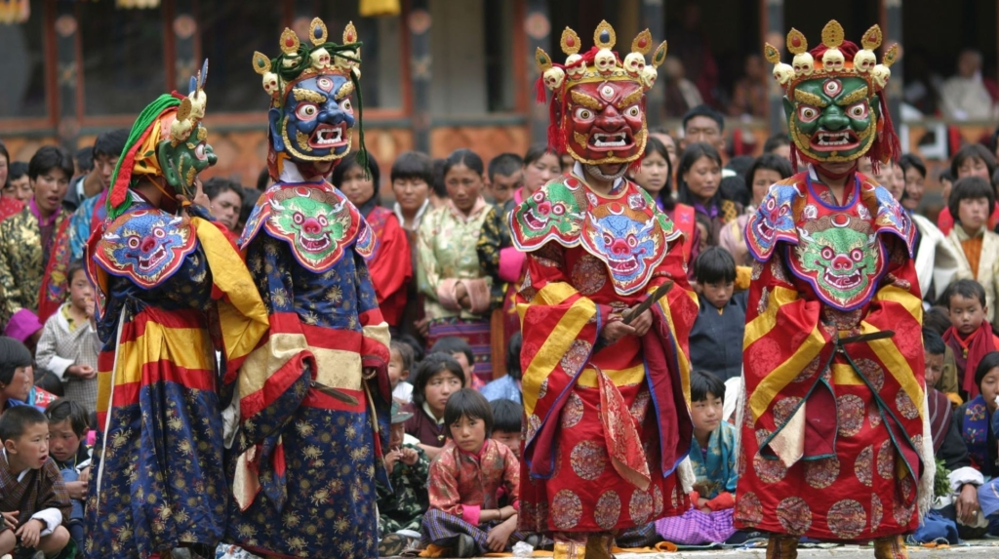

**(6 Nights / 7 Days) Drive In & Drive Out .**

**(Phuentsholing 1N – Thimphu 2N – Punakha 1N - Paro 2N)**

**Day 01: Bagdogra Airport – Phuentsholing**

Meet & Greet on arrival at Bagdogra airport and transfer to Phuentsholing/Jaigoan Boarder - The Gateway of Bhutan by Road from India. It is a thriving commercial center on the northern edge of the Indian Plains. On arrival check in at the hotel. Overnight stay at Phuentsholing.

**Day 02: Phuentsholing – Thimphu**

**(Distance: 176 kms. / Driving Time: 6 hrs. / Altitude of Thimphu: 2350 mts.)**

After breakfast complete the immigration formalities and transfer to Thimphu (7,710 ft.) the capital city of Bhutan. On arrival check in at the hotel. In the evening, visit the **Tashichho Dzong** (Fortress of the Glorious Religion). Overnight stay at Thimphu.

**Day 03: Thimphu Sightseeing**

After breakfast visit **Kuensel Phodrang** (Buddha Statue) a place for refreshing with a huge statue of Buddha on the top of the Kuensel Phodrang, N**ational Memorial Chorten** (Monument) & **Simply Bhutan (living museum)** will get one in house lady guide and **Takin Preserve Centre**, the national animal of Bhutan can be seen here. Stay in the hotel at Thimphu.

**Day 04: Thimphu – Punakha**

Drive to Punakha / Wangdue, On the way Stop at **Dochu-La-Pass** (3150 mts.). to view the higher Himalayas Arrival at Punakha visit **Punakha Dzong** - built in 1637 by Zhabdrung Ngawang Namgyal. For many years until the time of the second king, it served as the seat of the Government. The Dzong was named Druk Pungthang Dechen Phodrang (Palace of Great Happiness). Punakha is still the winter residence of Je-Khenpo and King Jigme Dorji Wangchuck convened the first National Assembly here in 1952. Stay at Hotels in Punakha.

**Day 05: Punakha - Paro Sightseeing**

After breakfast drive from Punakha to Paro, on the way stop **for TAMGCHOG IRON BRIDGE**. On the arrival check in to the hotel, if time permits explore Paro town. Evening visit Ta Dzong and Rinpung Dzong. Stay in Hotel at Paro.

**Day 06: Paro sightseeing**

After breakfast visit famous **Taktsang Monastery - called “Tiger's Nest**” (2-3 hrs hike from the base camp) & **Kyichu Monastery** / drive to chelela pass [**OPTIONAL ].** Overnight stay will be at Paro.

**Day 07: Paro – Phuentsholing / Jaigoan boarder / Bagdogra Airport**

After breakfast drive to Phuentsholing Jaigoan Boarder, on arrival change vehicle and processed towards your journey.

**END OF THE TOUR !!**

**INCLUDES**

* Accommodation on Double/ Twin Sharing Basis
* Accommodation in twin sharing basis
* Meal Serve in Hotel as per hotel fix menu basis.
* Exclusive Vehicle for transfers & sightseeing.
* Vehicle will be available as per itinerary only. Not at disposal. 9am-5pm.after 5 pm extra charges apply.
* Base category room used in the package.
* All hotel taxes etc.
* English speaking GUIDE AND driver throughout the tour. Only Bhutan part.
* One Local Sim card.
* One ltr mineral water bottle during sightseeing time only.
* SDF of 1200 per night per person
* Insurances of 600 per person

**EXCLUSIVE**

1. Tipping
2. Personal Insurance
3. Any personal consumption made which is not included in the package
4. Alcoholic drinks and special non Alcoholic cocktails, non-alcoholic beverages, aerated drinks and non-aerated drinks.
5. Laundry charges at hotel stays
6. Entrance fee at the historical monuments.

TASHI DELEK [THANK YOU]