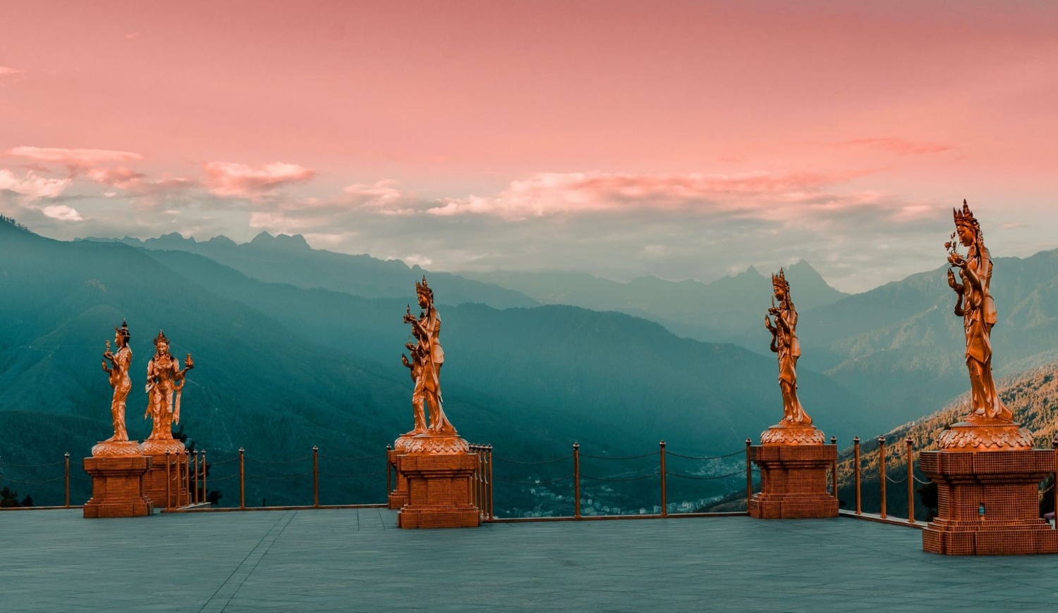

**7 NIGHTS AND 8 DAYS (Drive In Drive Out)**

|  |  |  |  |
| --- | --- | --- | --- |
| **No. of pax** | **3 Stars** | **4 Stars** | **5 Stars** |
| **02** | **44,100/-** | **65,300/-** | **1,07060** |
| **04** | **38,100/-** | **51,800/-** | **94,880** |
| **06** | **33,500/-** | **46,800/-** | **92,460** |
| **08** | **32,500/-** | **45,500/-** | **93,785** |
| **10** | **32,100/-** | **44,800/-** | **91,520** |

|  |  |  |  |
| --- | --- | --- | --- |
| **Child with Extra Bed** | **28,500/-** |  |  |
| **Child without Extra Bed** | **23,900/-** |  |  |

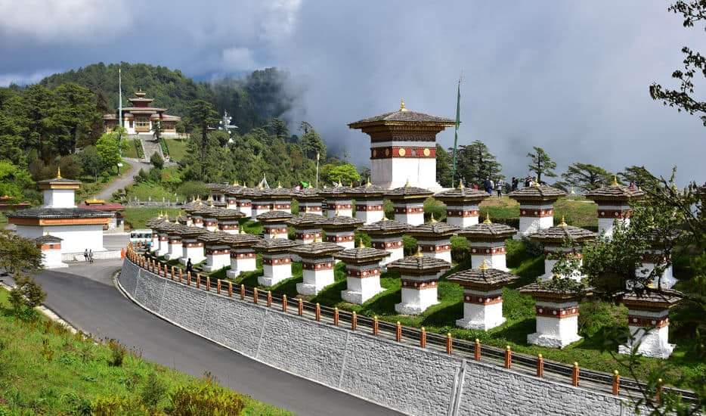

|  |  |  |
| --- | --- | --- |
| **No. of pax** | **Vehicle Types (Bhutan)** | **Vehicle Types**  **( India )** |
| **02 - 03** | **Creta / Santafee**  **Tucson / Seltos** | **Wagnor**  **SUV** |
| **04 -08** | **Etriga / Hiace** | **Innova** |
| **09 and above** | **Coaster Bus** | **Tempo Traveler** |

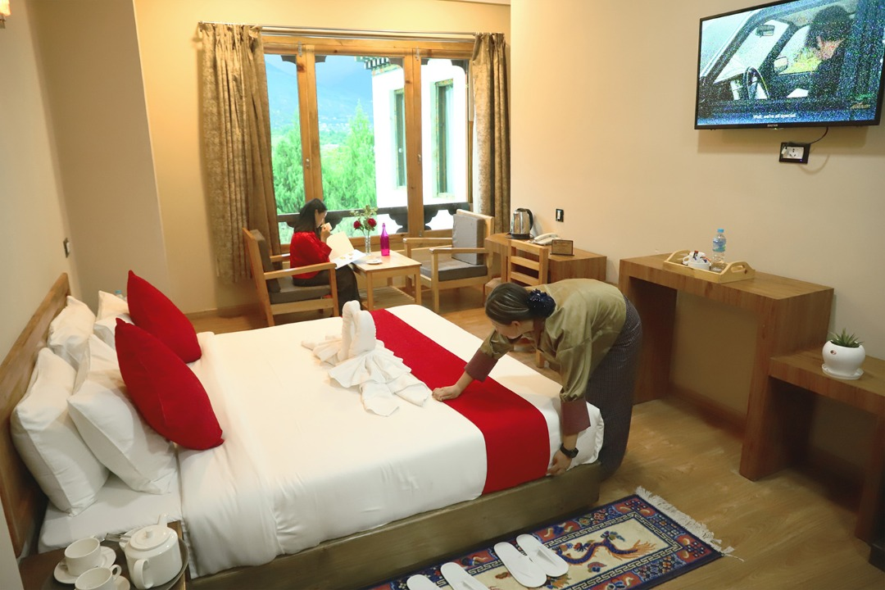

**3 Stars Hotels**

|  |  |  |
| --- | --- | --- |
| **Sl.no** | **Hotel Name** | **Location** |
| **1** | **Alem Resort / Meto Pema** | **Phuentsholing** |
| **2** | **Lhayul Hotel / Nordenma** | **Thimphu** |
| **3** | **Punakha Residency / Sonam Gang /** | **Punakha** |
| **4** | **Golden Paddy Filed / Tshongdu Boutique** | **Paro** |

**4 Stars Hotels**

|  |  |  |
| --- | --- | --- |
| **Sl.no** | **Hotel Name** | **Location** |
| **1** | **Palm Hotel / Ga Me Ga** | **Phuentsholing** |
| **2** | **Ramada Valley / Tashi Yidwong Grand / Pelyang Boutique** | **Thimphu** |
| **3** | **River Valley / Four Boutique / Zhingkham / Khuru Resort** | **Punakha** |
| **4** | **Tashi Namgay Resort / Paro Grand / Kaachi Grand** | **Paro** |

**5 Stars Hotels**

|  |  |  |
| --- | --- | --- |
| **Sl.no** | **Hotel Name** | **Location** |
| **1** | **Dusit Thane** | **Thimphu** |
| **2** | **Le Meridien** | **Paro** |
| **3** | **Palm Hotel / Ga Me Ga** | **Phuentsholing** |
| **4** | **RKPO / Dhensa Resort** | **Punakha** |

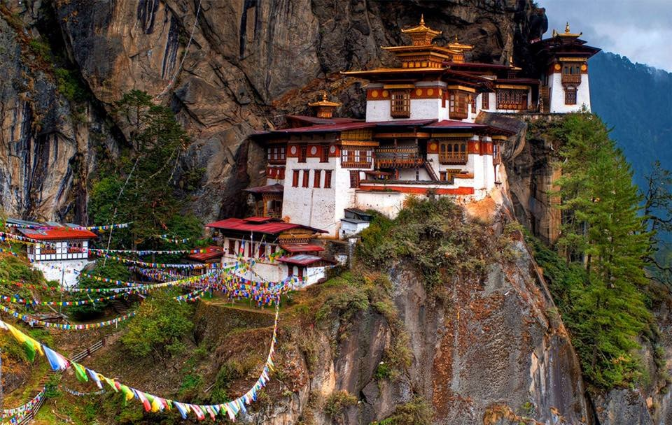

**7 Nights / 8 Days) Drive In & drive Out.**

**(Phuentsholing 2N – Thimphu 2N – Punakha 1N - Paro 2N)**

**Day 01: Bagdogra Airport – Phuentsholing**

Meet & Greet on arrival at Bagdogra airport and transfer to Phuentsholing/Jaigoan Boarder - The Gateway of Bhutan by Road from India. It is a thriving commercial center on the northern edge of the Indian Plains. On arrival check in at the hotel. Overnight stay at Phuentsholing.

**Day 02: Phuentsholing – Thimphu**

**(Distance: 176 kms. / Driving Time: 6 hrs. / Altitude of Thimphu: 2350 mts.)**

After breakfast complete the immigration formalities and transfer to Thimphu (7,710 ft.) the capital city of Bhutan via Chhukha stopping over for lunch and see hydro power from view point. On arrival check in at the hotel. In the evening, visit the **Tashichho Dzong** (Fortress of the Glorious Religion) and visit Market for Lesiure. Overnight stay at Thimphu.

**Day 03: Thimphu Sightseeing**

After breakfast visit **Kuensel Phodrang** (Buddha Statue) a place for refreshing with a huge statue of Buddha on the top of the Kuensel Phodrang, N**ational Memorial Chorten** (Monument) & **Simply Bhutan (living museum) will get in house lady guide** and **Takin Preserve Centre**, the national animal of Bhutan can be seen here. Stay at Thimphu

**Day 04: Thimphu – Punakha**

Drive to Punakha, on the way stop at **Dochu-La-Pass** (3150 mts.) to view the higher Himalayas. Glace at **LAMPARI PARK when on the way to punakha.** Arrival at Punakha visit **Punakha Dzong** - built in 1637 by Zhabdrung Ngawang Namgyal. For many years until the time of the second king, it served as the seat of the Government. The Dzong was named Druk Pungthang Dechen Phodrang (Palace of Great Happiness). Punakha is still th winter residence of Je-Khenpo and King Jigme Dorji Wangchuck convened the first National Assembly here in 1952. Overnight stay at Punakha.

**Day 05: Punakha - Paro Sightseeing**

After breakfast Do RAFTING I guest want to do, after rafting drive from Punakha to Paro on than way stop **for TAMGCHOG IRON BRIDGE**, check in to the hotel, if time permits explore Paro town. Stay in Hotel at Paro.

**Day 06: Paro sightseeing**

After breakfast visit famous **Taktsang Monastery - called “Tiger's Nest**” (2-3 hrs hike from the base camp) & **Kyichu Monastery**/ drive to chelela pass [**OPTIONAL].** Evening visit Ta Dzong and Rinpung Dzong. Overnight stay will be at Paro.

**Day 07: Paro - Phuentsholing**

After breakfast drive to Phuentsholing, on arrival check in and evening explore town. Overnight stay at hotel.

**Day 08: Phuentsholing - Jaigoan boarder / Bagdora**

Next day after breakfast drive to Phuentsholing Jaigoan boarder and transfer for further journey with memories.

**END OF THE TOUR!!**

**COST INCLUDES:**

**. Accommodation on Double/ Twin Sharing Basis.**

**· Meal plan MAP basis.**

**· Exclusive Vehicle for transfers & sightseeing.**

**. Vehicle will be available as per itinerary only. Not at disposal. 9am-5pm. after 5 pm extra charges apply.**

**· All hotel taxes etc.**

**. English speaking GUIDE AND driver throughout the tour.**

**. SDF of 1200 per night per person**

**. Insurances of 600 per person.**

**Package Cost Excludes:**

**1.Tipping**

**2. Personal Insurance**

**3. Any personal consumption made which is not included in the package**

**4. Alcoholic drinks and special non Alcoholic cocktails, non-alcoholic beverages, aerated drinks, and non-aerated drinks.**

**5. Laundry charges at hotel stays.**

**6. Entrance fees at the HISTORICAL MONUMENTS.**

**7. Lunch in whole tour.**

**TASHI DELEK**