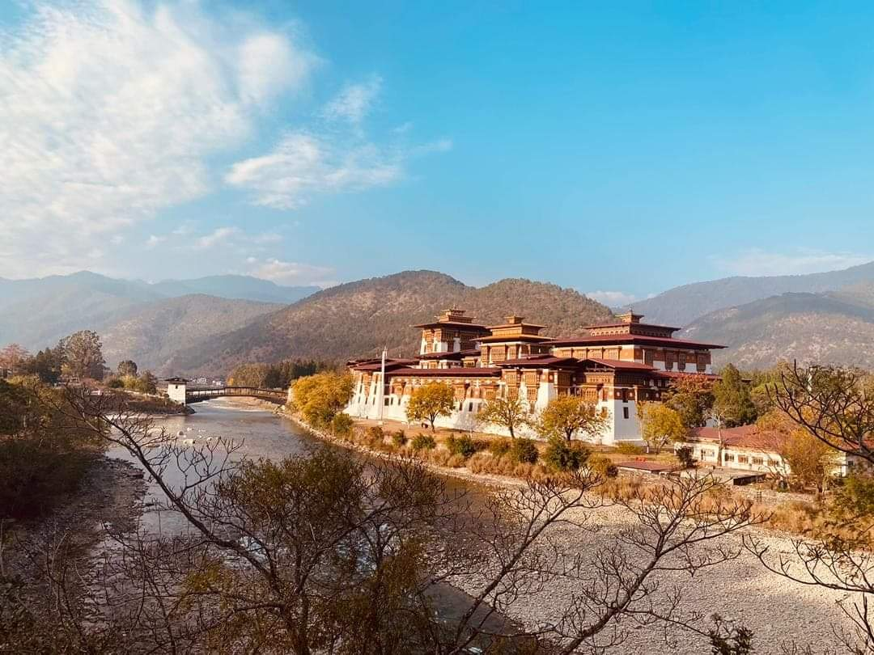

**8 NIGHTS AND 9 DAYS (Drive In Drive Out)**

|  |  |  |  |
| --- | --- | --- | --- |
| **No. of pax** | **3 Stars** | **4 Stars** | **5 Stars** |
| **02** | **52,100/-** | **68,300/-** | **1,00,700/-** |
| **04** | **38,900/-** | **55,100/-** | **87,500/-** |
| **06** | **35,690/-** | **51,890/-** | **84,290/-** |
| **08** | **37,700/-** | **53,900/-** | **86,300/-** |
| **10** | **35,060/-** | **51,260/-** | **82,820/-** |

|  |  |  |  |
| --- | --- | --- | --- |
| **Child with Extra Bed** |  |  |  |
| **Child without Extra Bed** |  |  |  |

|  |  |  |
| --- | --- | --- |
| **No. of pax** | **Vehicle Types (Bhutan)** | **Vehicle Types**  **( India )** |
| **02 - 03** | **Creta / Santafee**  **Tucson / Celtos** | **Wagnor**  **SUV** |
| **04 -08** | **Etriga / Hiace** | **Innova** |
| **09 and above** | **Coaster Bus** | **Tempo Traveler** |

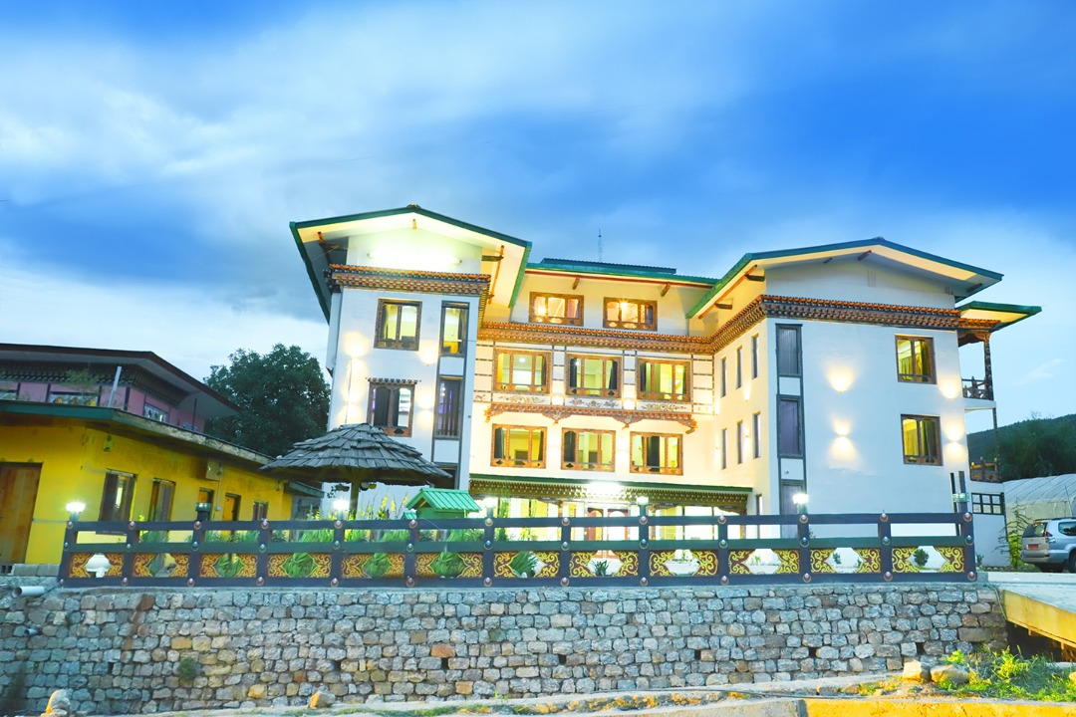

**3 Stars Hotels**

|  |  |  |
| --- | --- | --- |
| **Sl.no** | **Hotel Name** | **Location** |
| **1** | **Alem Resort / Meto Pema** | **Phuentsholing** |
| **2** | **Lhayul Hotel / Nordenma** | **Thimphu** |
| **3** | **Punakha Residency / Sonam Gang / Meri Puensum** | **Punakha** |
| **4** | **Golden Paddy Field / Tshongdu Boutique** | **Paro** |

**4 Stars Hotels**

|  |  |  |
| --- | --- | --- |
| **Sl.no** | **Hotel Name** | **Location** |
| **1** | **Palm Resort / Ga Me Ga** | **Phuentsholing** |
| **2** | **Ramada Valley / Tashi Yidwong Grand / Pelyang Boutique** | **Thimphu** |
| **3** | **Four Boutique / River Valley / Khuru / Zhingkham Resort** | **Punakha** |
| **4** | **Tashi Namgay Resort / Paro Grand / Kaachi Grand** | **Paro** |

**5 Stars Hotels**

|  |  |  |
| --- | --- | --- |
| **Sl.no** | **Hotel Name** | **Location** |
| **1** | **Palm Hotel / Ga Me Ga** | **Phuentsholing** |
| **2** | **Dusit Thane** | **Thimphu** |
| **3** | **Le Meridien** | **Paro** |
| **4** | **RKPO / Dhensa** | **Punakha** |

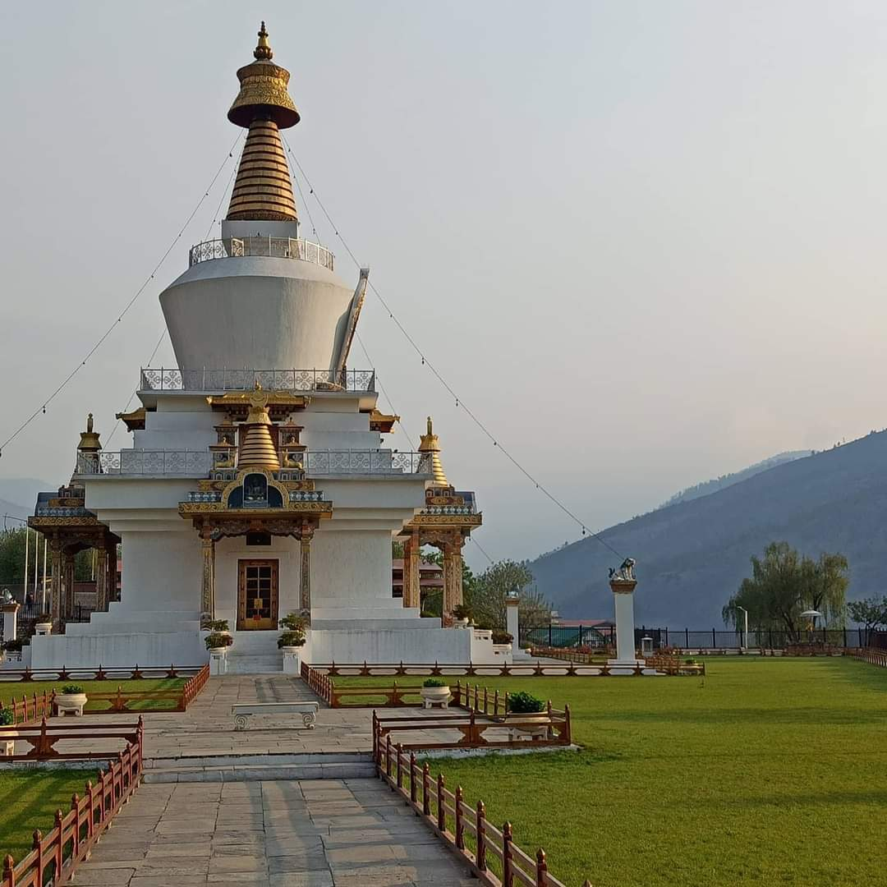

**(8 Nights / 9 Days) Drive In & Drive Out** **.**

**(Phuentsholing 2N – Thimphu 2N – Punakha 2N - Paro 2N)**

**Day 01: Bagdogra Airport – Phuentsholing**

Meet & Greet on arrival at Bagdogra airport and transfer to Phuentsholing/Jaigoan Boarder - The Gateway of Bhutan by Road from India. It is a thriving commercial center on the northern edge of the Indian Plains. On arrival check in at the hotel. Overnight stay at Phuentsholing.

**Day 02: Phuentsholing – Thimphu**

**(Distance: 176 kms. / Driving Time: 6 hrs. / Altitude of Thimphu: 2350 mts.)**

After breakfast complete the immigration formalities and transfer to Thimphu (7,710 ft.) the capital city of Bhutan. On arrival check in at the hotel. In the evening, visit the **Tashichho Dzong** (Fortress of the Glorious Religion). Overnight stay at Thimphu.

**Day 03: Thimphu sightseeings**

After breakfast visit **Kuensel Phodrang** (Buddha Statue) a place for refreshing with a huge statue of Buddha on the top of the Kuensel Phodrang, N**ational Memorial Chorten** (Monument) & **Simply Bhutan (living museum) will get in house lady guide and Painting schools if possible**. **Takin Preserve Centre**, the national animal of Bhutan can be seen here. Overnight stay at Thimphu.

**Day 04: Thimphu – Punakha**

After breakfast drive to **punakha via Dochula pass**, stop for **Lampari park** for a glace, Arrival at Punakha visit **Punakha Dzong** - built in 1637 by Zhabdrung Ngawang Namgyal. For many years until the time of the second king, it served as the seat of the Government. The Dzong was named Druk Pungthang Dechen Phodrang (Palace of Great Happiness). Punakha is still the winter residence of Je-Khenpo and King Jigme Dorji Wangchuck convened the first National Assembly here in 1952. Stay in hotel at Punakha.

**Day 05: Punakha Sightseeing**

After breakfast go for **Rafting in Punakha**, visit Chimmi Lhakhang. Evening time relax time, stay at Punakha.

**Day 06**: **Punakha – Paro**

After breakfast drive to Paro. On the way to paro Visit **Tamchog Lhangkhag [Iron Bridge**]. Overnight stay will be at Paro. Explore town and visit **Airport view.**

**Day 07: Paro Sightseeing**

After breakfast visit famous **Taktsang Monastery - called “Tiger's Nest**” (2-3 hrs hike from the base camp) & **Kyichu Monastery**. Evening visit **Ta Dzong and Rinpung Dzong, Hot stone bath** [OPTIONAL]. Overnight stay will be at Paro.

**Day 08: Paro – Phuentsholing**

After breakfast drive to Phuentsholing, on arrival stay at Hotel.

**Day 09: Jaigoan - Bagdogra Airport**

After breakfast check out from the hotel and drive to the airport transfer with smiling faces.

**END OF THE TOUR!!**

**INCLUDES**

* Accommodation on Double/ Twin Sharing Basis
* Accommodation in twin sharing basis
* Meal Serve in Hotel as per hotel fix menu basis.
* Exclusive Vehicle for transfers & sightseeing.
* Vehicle will be available as per itinerary only. Not at disposal. 9am-5pm.after 5 pm extra charges     apply.
* Base category room used in the package.
* All hotel taxes etc.
* English speaking GUIDE AND driver throughout the tour. Only Bhutan part.
* One Local Sim card.
* One ltr mineral water bottle during sightseeing time only.
* SDF of 1200 per night per person
* Insurances of 600 per person

**EXCLUSIVE**

1. Tipping
2. Personal Insurance
3. Any personal consumption made which is not included in the package
4. Alcoholic drinks and special non Alcoholic cocktails, non-alcoholic beverages, aerated drinks and non-aerated drinks.
5. Laundry charges at hotel stays
6. Entrance fee at the historical monuments.

TASHI DELEK [THANK YOU]