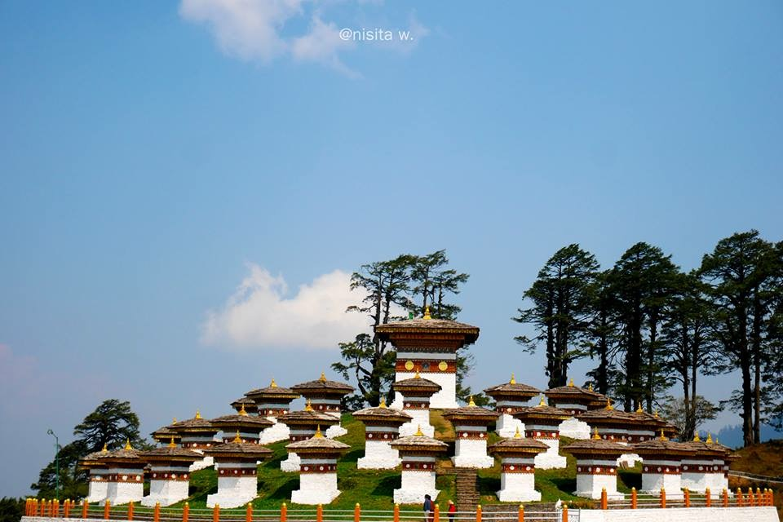

**8 NIGHTS AND 9 DAYS (Fly In Fly Out)**

|  |  |  |  |
| --- | --- | --- | --- |
| **No. of pax** | **3 Stars** | **4 Stars** | **5 Stars** |
| **02** | **49,940/-** | **69,800/-** | **1,14,500/-** |
| **04** | **37,940/-** | **57,800/-** | **1,02,500/-** |
| **06** | **35,540/-** | **55,400/-** | **1,00,100/-** |
| **08** | **36,740/-** | **56,600/-** | **1,01,300/-** |
| **10** | **34,580/-** | **54,400/-** | **99,140/-** |

|  |  |  |  |
| --- | --- | --- | --- |
| **Child with Extra Bed** |  |  |  |
| **Child without Extra Bed** |  |  |  |

|  |  |
| --- | --- |
| **No. of pax** | **Vehicle Types (Bhutan)** |
| **02 - 03** | **Creta / Santafee**  **Tucson / Celtos** |
| **04 -08** | **Etriga / Hiace** |
| **09 and above** | **Coaster Bus** |

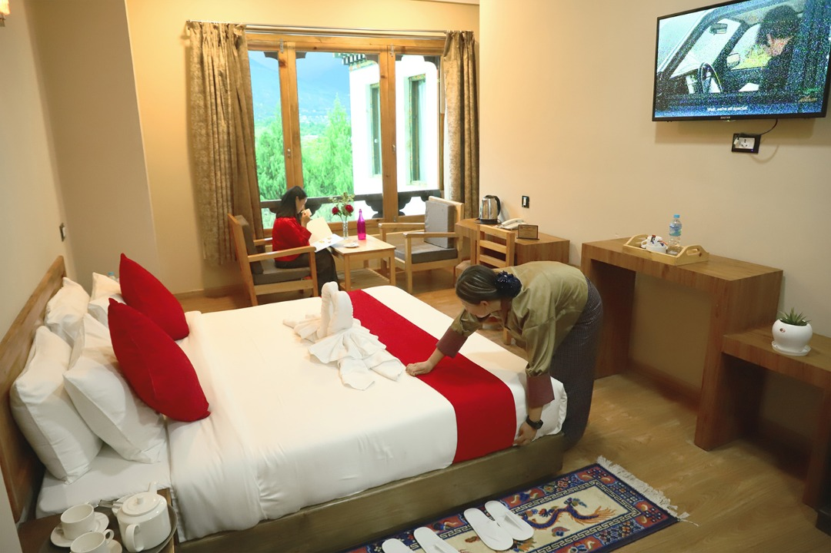

**3 Stars Hotels**

|  |  |  |
| --- | --- | --- |
| **Sl.no** | **Hotel Name** | **Location** |
| **1** | **Lhayul Hotel / Nordenma** | **Thimphu** |
| **2** | **Punakha Residency / Sonam Gang /** | **Punakha** |
| **3** | **Golden Paddy Field / Tshongdu Boutique** | **Paro** |

**4 Stars Hotels**

|  |  |  |
| --- | --- | --- |
| **Sl.no** | **Hotel Name** | **Location** |
| **1** | **Ramada Valley / City Hotel / Ariya Hotel** | **Thimphu** |
| **2** | **Four Boutique / River Valley / Khuru / Zhingkham** | **Punakha** |
| **3** | **Tashi Namgay Resort / The Grand Hotel / Kaachi Grand** | **Paro** |

**5 Stars Hotels**

|  |  |  |
| --- | --- | --- |
| **Sl.no** | **Hotel Name** | **Location** |
| **1** | **Dusit Thane** | **Thimphu** |
| **2** | **Le Meridien** | **Paro** |
| **3** | **RKPO** | **Punakha** |

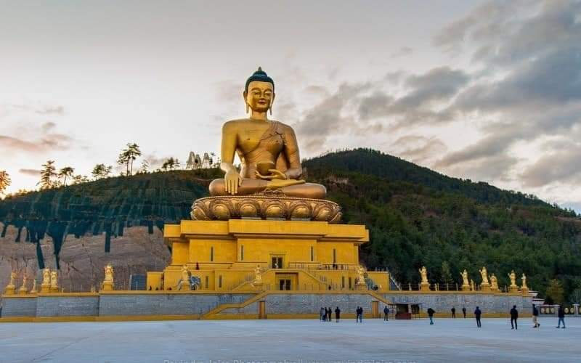

**(8 Nights / 9 Days) Fly In & Fly Out** **.**

**(Thimphu 3N – Punakha 2N - Paro 3N)**

|  |  |  |
| --- | --- | --- |
| **Day** | **Plan** | **Night Stay** |
| **Day 1** | **Pick from Paro airport, drive to Thimphu sightseeing.** | **Thimphu** |
| **Day 2** | **After Breakfast start your day with sightseeing at Thimphu visiting memrorial chorten, Buddha statue and Simply Bhutan. Visit Tashichho Dzong (Fortress of the Glorious Religion)**  **Stay at Thimphu .** | **Thimphu** |
| **Day 3** | **After breakfast drive to Punakha via Dochula pass for the sightseeing On the way Stop at Dochu-La-Pass (3150 mts.) to view the higher Himalayas. Stay in Hotel.** | **Thimphu** |
| **Day 4** | **Drive Thimphu to Punakha and on the way stop at Dochu-La-Pass (3150 mts.) to view the higher Himalayas.  Visit Punakha Dzong - built in 1637 and Punakha sightseeing and stay in Punakha.** | **Punakha** |
| **Day 5** | **After breakfast take a short excursion trip to visit the Chhimi Lhakhang – The Temple, also known as “The Temple of Fertility” was built by Lama Drukpa Kuenley, “The Devine Mad Man”. Evening free for leisure. Overnight stay will be at Punakha.** | **Punakha** |
| **Day 6** | **After breakfast drive Punakha to Paro sightseeing.**  **On the way Paro via Dochula , stop for Iron bridge on the way and upon arrival check in to the hotel .** | **Paro** |
| **Day 7** | **Taktsang Monastery - called “Tiger's Nest” (2-3 hrs hike from the base camp) &Kyichu Monastery Evening visit Ta Dzong and Rinpung Dzong. Overnight stay at hotel.** | **Paro** |
| **Day 8** | **Drive to chelela pass to see the mountains top and scenic view.**  **Paro local sightseeing with some leisure time and shopping.** | **Paro** |
|  |  |  |
| **DAY 09** | **Drive to airport for next destination with memories** | **Destination** |
|  |  |  |
|  |  |  |
|  |  |  |
|  |  |  |
|  |  |  |
|  |  |  |

**END OF THE TOUR!!!**

**INCLUDES**

* Accommodation on Double/ Twin Sharing Basis
* Accommodation in twin sharing basis
* Meal Serve in Hotel as per hotel fix menu basis.
* Exclusive Vehicle for transfers & sightseeing.
* Vehicle will be available as per itinerary only. Not at disposal. 9am-5pm.after 5 pm extra charges     apply.
* Base category room used in the package.
* All hotel taxes etc.
* English speaking GUIDE AND driver throughout the tour. Only Bhutan part.
* One Local Sim card.
* One ltr mineral water bottle during sightseeing time only.
* SDF of 1200 per night per person
* Insurances of 600 per person

**EXCLUSIVE**

1. Tipping
2. Personal Insurance
3. Any personal consumption made which is not included in the package
4. Alcoholic drinks and special non Alcoholic cocktails, non-alcoholic beverages, aerated drinks and non-aerated drinks.
5. Laundry charges at hotel stays
6. Entrance fee at the historical monuments.

TASHI DELEK [THANK YOU]